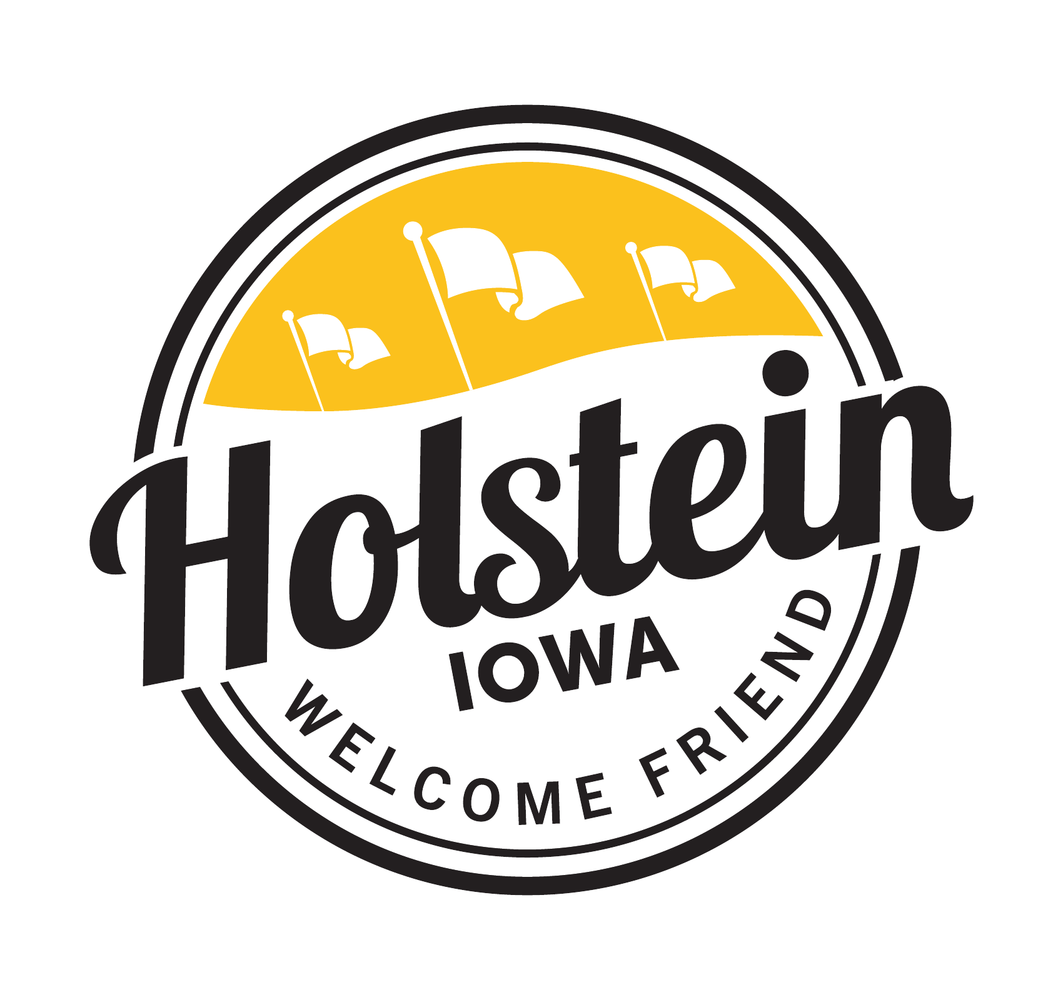
HOLSTEIN CITY COUNCIL
REGULAR MEETING
Tuesday, October 28, 2025
5:00 PM – Holstein City Hall Council Chambers
POSTED 09/08/2025
City Hall
Library
Post Office
Signature_________________

AGENDA
CALL TO ORDER
PLEDGE OF ALLEGIANCE
ROLL CALL OF COUNCIL MEMBERS

CONSENT AGENDA
All items under the Consent Agenda will be enacted by one motion. Those items will not be discussed separately unless a request is made before the council votes on the motion.
- Minutes of October 14, 2025, Regular Council Meeting
- Claims
- Approval of A&A Food & Fuel, LLC Class B Alcohol License

CITIZEN FORUM
This time is set aside for public comments regarding issues not on the agenda. No action or discussion shall take place at this time on issues brought before the council.

BUSINESS
- Austin Thevenot – Business at the Property Located at 416 N Main
- ISG – Tom Grafft – Sewer I&I Plan Proposal, Road Improvement Plan Proposal and Benning Drive Stormwater
- Resolution 25-55 Authorizing the Mayor and City Administrator to Execute a Waterline Easement Between the Dessel-Schmidt Post #225 of the American Legion and the City of Holstein for 125 N Main Park
- Resolution 25-56 Authorizing the Mayor and City Administrator to Execute a Development Agreement Between Linda M. Klotz and Steven E. Klotz and The City of Holstein
- Resolution 25-57 Authorizing the Mayor and City Administrator to Execute a Real Estate Purchase Agreement Between Linda M. Klotz and Steven E. Klotz and the City of Holstein
- Discuss 313 Railroad Street
- Pickleball Court Updates – Josh Jensen and Parks Committee
- Approval of Scott Niemeier CEU

ADJOURN

