POSTED 08/24/2026
City Hall
Library
Post Office
Signature_________________
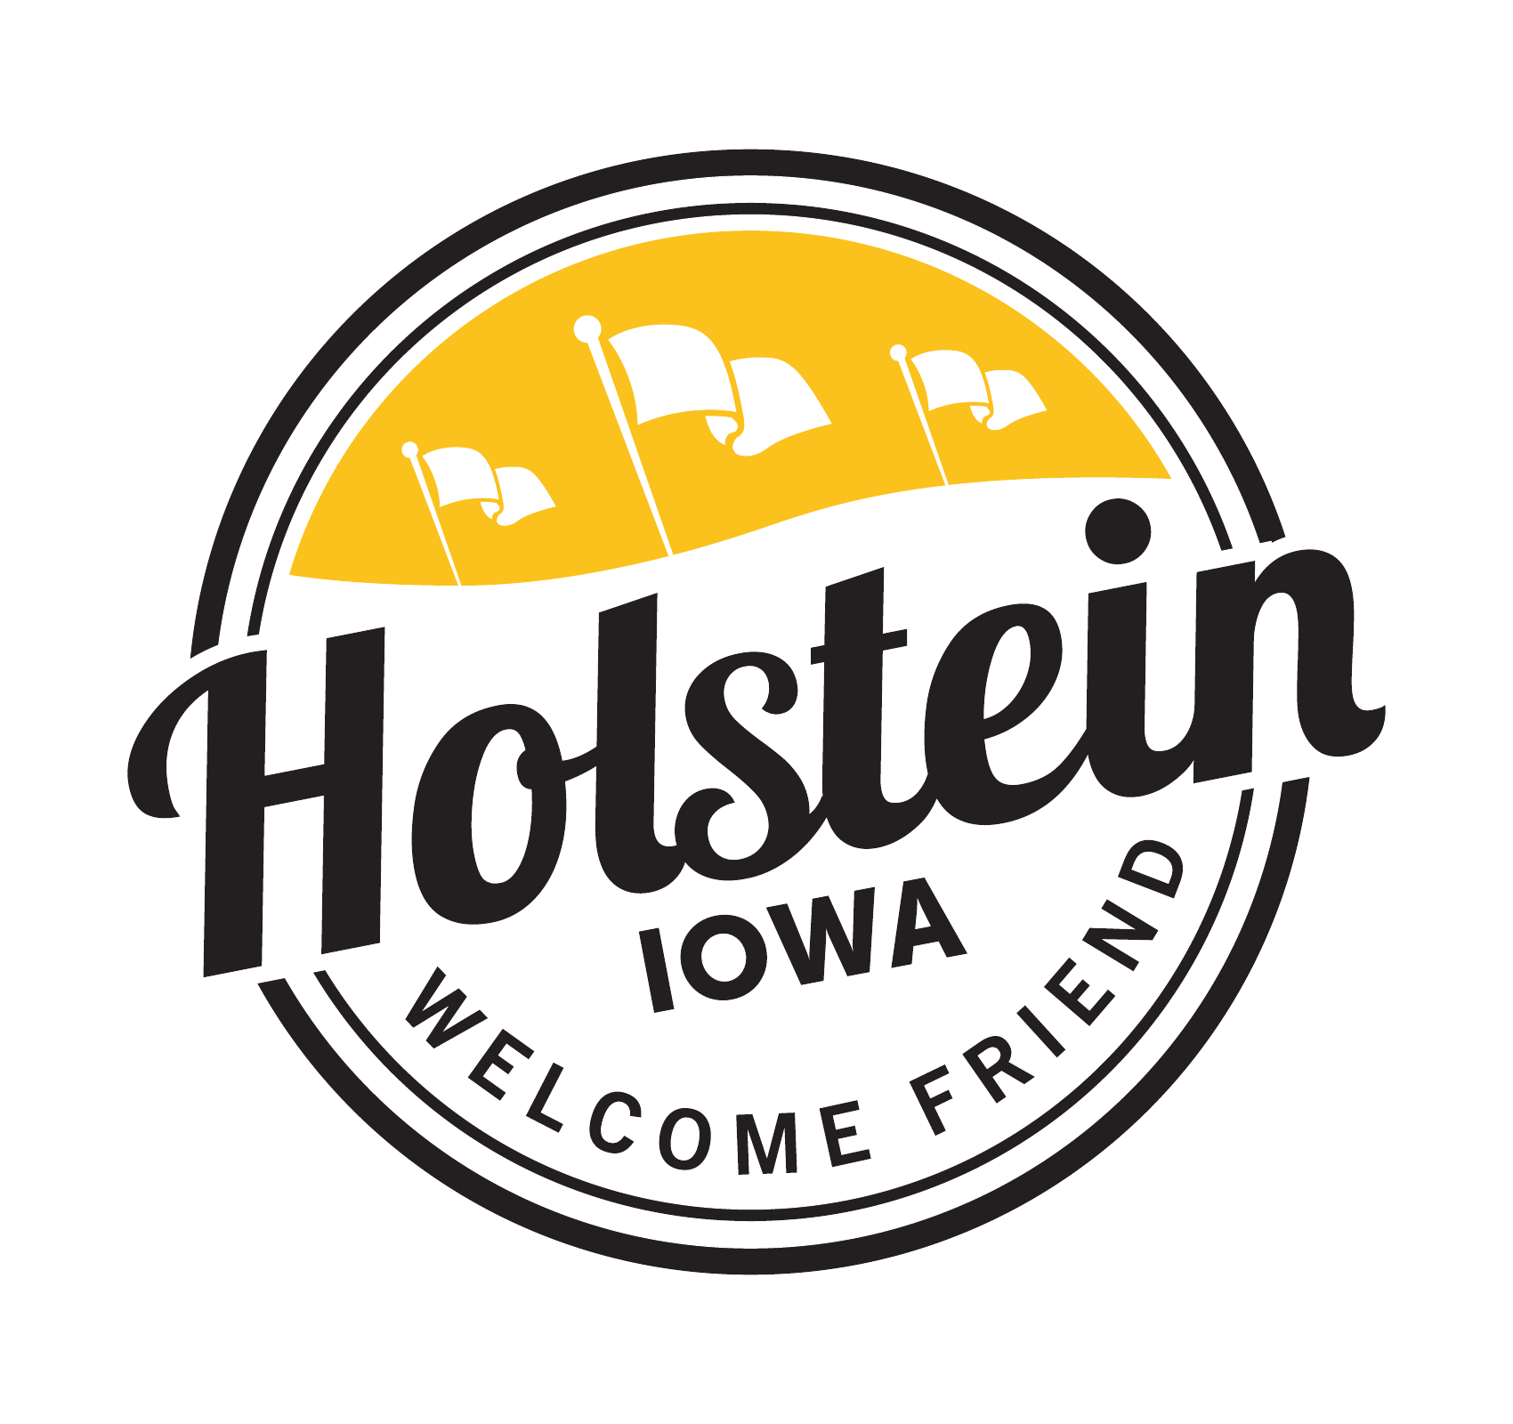
HOLSTEIN CITY COUNCIL
SPECIAL COUNCIL MEETING
Tuesday, August 25, 2026
5:00 PM – Holstein City Hall Council Chambers

AGENDA
CALL TO ORDER
PLEDGE OF ALLEGIANCE
ROLL CALL OF COUNCIL MEMBERS

BUSINESS
- Holstein Uran Renewal Area 3 amendment consultation Session with Ida County and Ridge View Community School District
- Public Hearing Urban Renewal Plan
- Public hearing on proposal to enter into a General Obligation Sewer Improvement Loan and Disbursement Agreement
- Resolution 26-40 taking additional action on proposal to enter into a General Obligation Sewer Improvement Loan and Disbursement Agreement and combining Loan and Disbursement Agreements
- Discussion City Owned Property located at 112 E 2nd St
- Resolution 26-39 Establishing A Plan for the City-Owned Property Located At 112 East 2nd Street, Holstein, Iowa

ADJOURN

